RETAIL SALES, ITEM & OUTLET PERFORMANCE ANALYSIS
1. Project Overview and Objective
To perform exploratory data analysis and predictive modelling on the Sales dataset to identify key drivers of product sales across different retail outlets, enabling data-driven inventory optimization and revenue forecasting strategies.
This project involves cleaning, transforming, and analysing raw data and creating an interactive Power BI dashboard to derive meaningful business insights.

2. Data Sources
- Source Description and Timeline: Hugging Face - 22Years (1985-2009)
- Domain: Retail

3. Problem Statement
- To Calculate how much revenue a specific product will make at a given store location.
- To find out how price, product placement, and category affect sales.
- To Help managers stock the right items and place high-selling products on better shelves.
- To Use data insights to choose where to open new stores and which products to feature.
- To create meaningful visualizations that clearly explain the story behind the data

4. Attribute (Column /Features) Details:
Attribute Name | Data Type | Description
Item_Identifier | Categorical (String) | Unique ID assigned to each product.
Item_Weight | Numerical (Float) | Weight of the product.
Item_Fat_Content | Categorical (String) | Indicates whether the product is low fat or regular.
Item_Visibility | Numerical (Float) | Percentage of total display area allocated to the item in the store shelf.
Item_Type | Categorical (String) | Category of the product.
Item_MRP | Numerical (Float) | Maximum Retail Price of the product.
Outlet_Identifier | Categorical (String) | Unique ID assigned to each store location.
Outlet_Establishment_Year | Numerical (Integer) | Year the specific store was opened.
Outlet_Size | Categorical (String) | Ground area size of the store (Small, Medium, High).
Outlet_Location_Type | Categorical (String) | City tier rating of the store's location (Tier 1, Tier 2, Tier 3).
Outlet_Type | Categorical (String) | Classification of store format (Supermarket Type1, Type2, Type3, Grocery Store).
Item_Outlet_Sales | Numerical (Float) | Total sales revenue generated by the item at that particular outlet (Target Variable).

5. Tools & Technologies
- Python: Data cleaning.
- Power BI: Data modelling, DAX calculations, visualization, and interactive dashboard creation.

6. Data Pre-Processing (Power Query)
Tasks Performed:
- Data Cleaning & Transformation: Removed duplicates, handled missing values, standardized formats, and created calculated fields.

7. Data Modelling and DAX (Power BI)
- Calculated Columns & DAX Measures
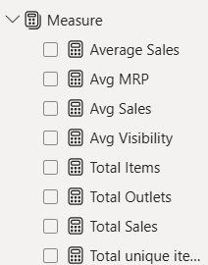

Average Sales = AVERAGE('Cleaned_Data'[Item_Outlet_Sales])
Avg MRP = AVERAGE('Cleaned_Data'[Item_MRP])
Avg Sales = AVERAGE('Cleaned_Data'[Item_Outlet_Sales])
Avg Visibility = AVERAGE('Cleaned_Data'[Item_Visibility])
Total Items = COUNTROWS('Cleaned_Data')
Total Outlets = DISTINCTCOUNT('Cleaned_Data'[Outlet_Identifier])
Total Sales = SUM('Cleaned_Data'[Item_Outlet_Sales])
Total unique items = DISTINCTCOUNT('Cleaned_Data'[Item_Identifier])

8. Analysis and Visualizations (Power BI)
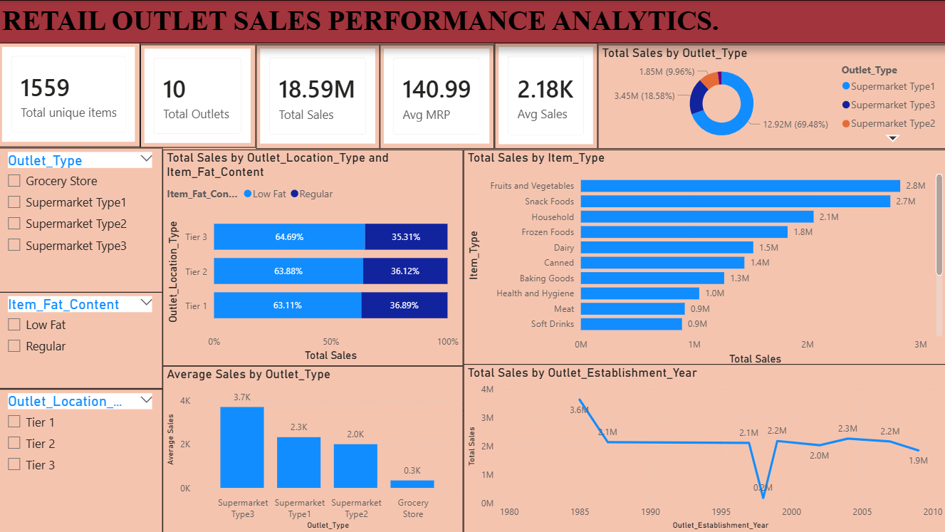

9. Insights & Conclusions:
1. Descriptive Analysis:
Total Revenue: Your stores generated 18.59M Crore in total sales across 10 outlets and 1,559 products.
Top Best-Sellers: Fruits & Vegetables (2.8 M) and Snack Foods (2.7 M) brought in the highest sales.
Customer Choice: Low Fat products made up 64% of total sales compared to Regular products 36%.
2. Diagnostic Analysis:
Store Format: Supermarket Type 3 made the most money per order because bigger supermarkets offer more variety and higher-priced items.
Store Size: Medium-sized stores performed better than large (High-sized) stores, showing that bigger space doesn't always mean higher sales.
Small Stores Struggled: Small Grocery Stores had very low sales because they carry fewer products and have limited space.
3. Predictive Analysis:
Healthy Product Demand: Sales for Low Fat items will continue to grow as customers focus more on health.
Medium Store Success: Opening Medium-sized supermarkets will consistently bring in higher sales than opening small grocery shops.
Popular Items: High demand for Fruits, Vegetables, and Snack Foods will remain steady throughout the year.
4. Prescriptive Analysis:
Stock Top Products: Keep high inventory for Fruits & Vegetables and Snack Foods so you never run out of stock.
Focus on Medium Supermarkets: Expand by opening more Medium-sized Supermarkets instead of small grocery stores.
Promote Low Fat Items: Give better shelf display to Low Fat items to boost revenue further.
Fix Small Stores: Add special discounts or popular everyday items to small grocery stores to increase their sales.

10. Conclusions
The dashboard shows that product price (Item MRP) and store type (Outlet Type) have the biggest effect on overall sales.
Placing items where customers can easily see them clearly helps boost total sales in every store.
Using sales predictions helps store managers pick the right items to stock instead of relying on pure guesswork.
Showing both actual past sales and expected future sales in one place gives leaders a quick, clear view of business performance.
This project creates a solid foundation that can easily expand later to include live stock tracking and automatic updates.

